## [**https://github.com/utsavsingh22/AzureDataEngineerProjects**](https://github.com/utsavsingh22/AzureDataEngineerProjects)

## **Question 1:**

## 1. Create a ADLS storage account with the name: yourname+yourdob+adls

## 2. While making ensure it is in the resource group name: - Azurelib-Academy and the region is US-east

#Step1:-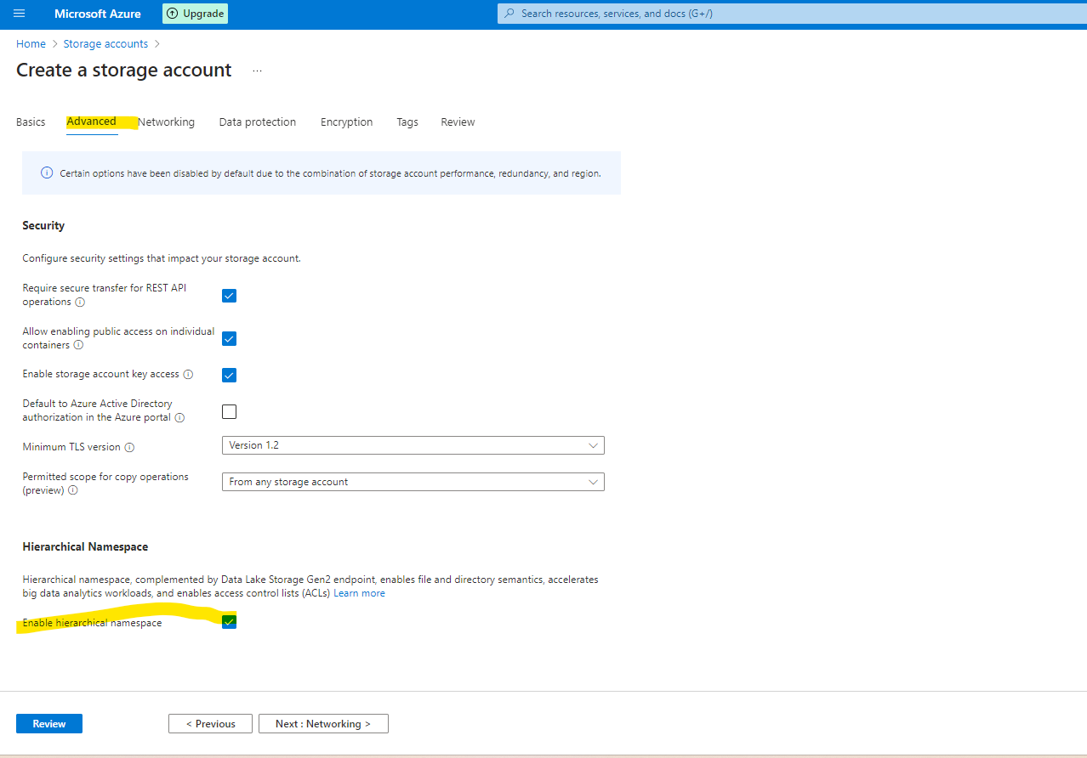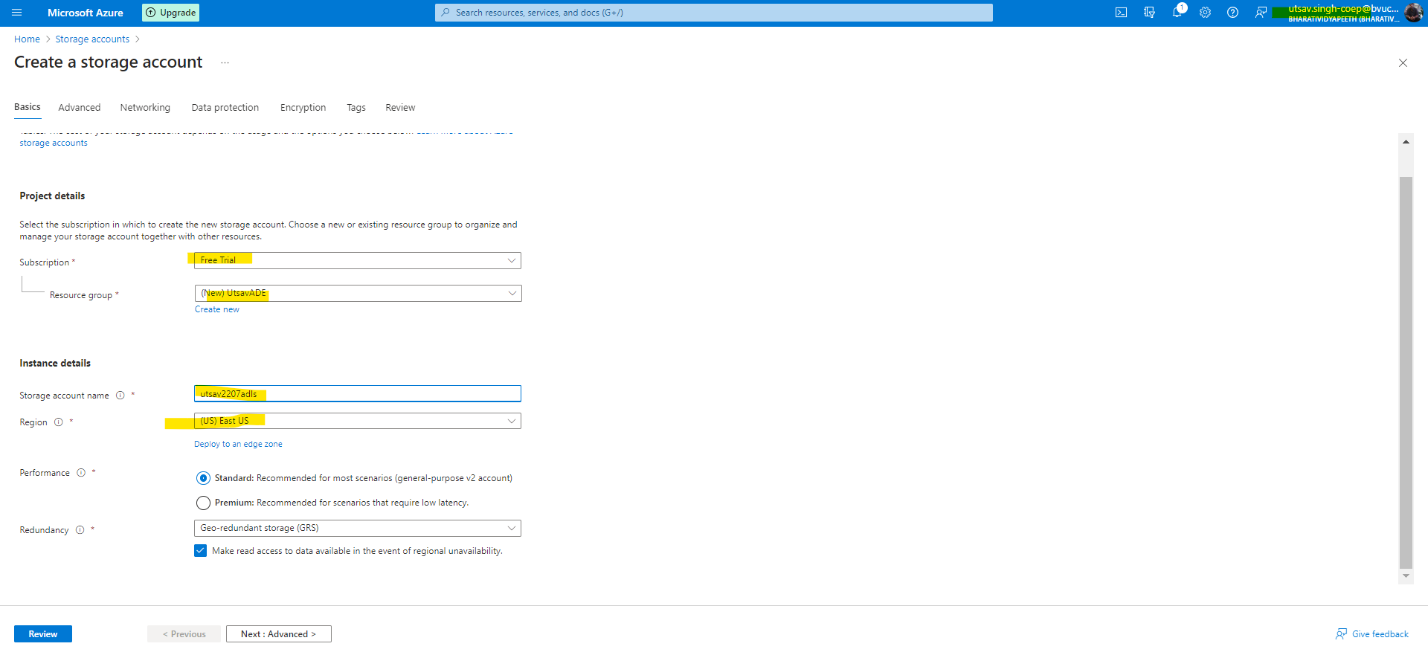

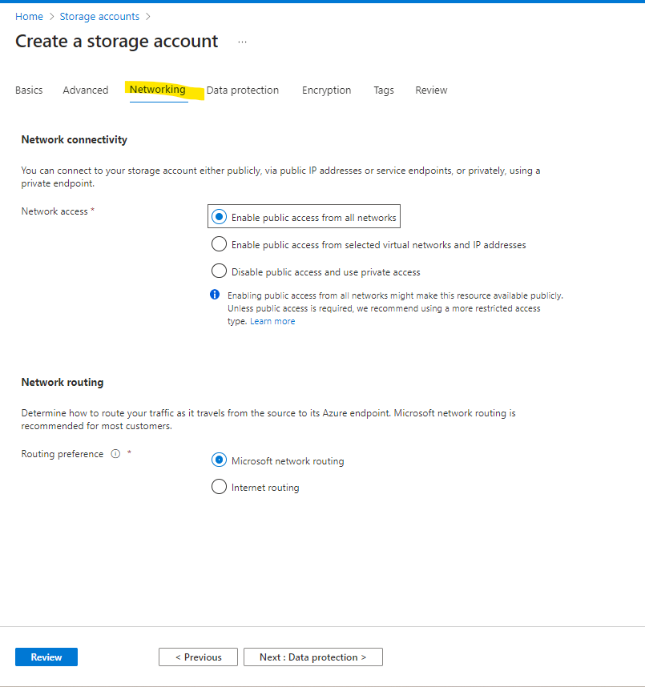

## 3. Try to change the soft delete time for 7 days to 10 days.

#Step2:-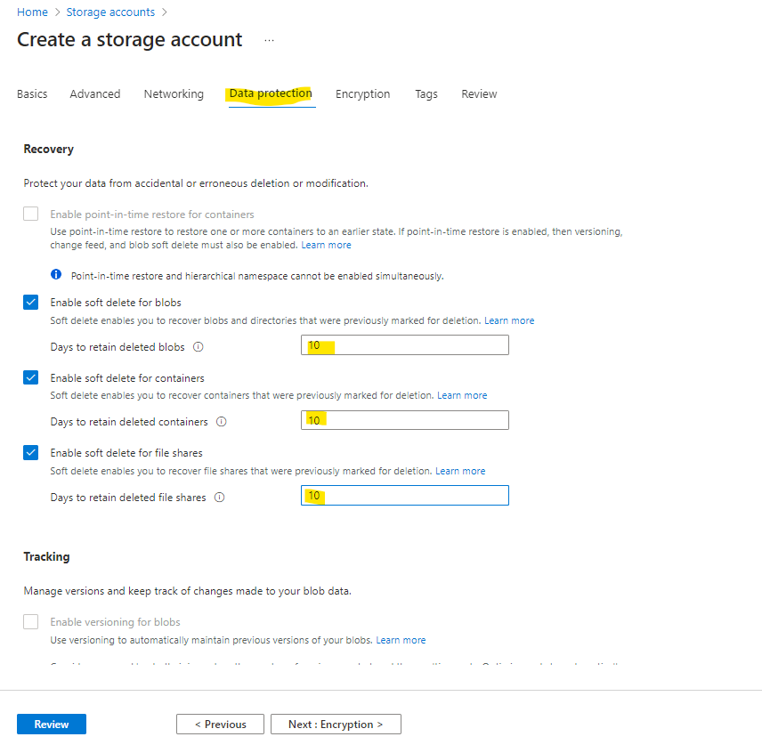

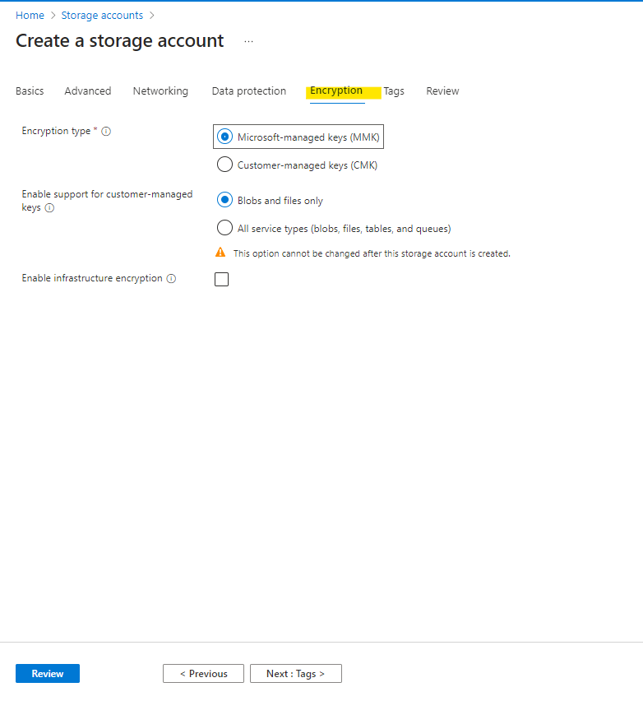

## 4. Create a container name landing (publicly accessible)

## 5. Create another container name raw private (publicly not accessible)

#Step3:-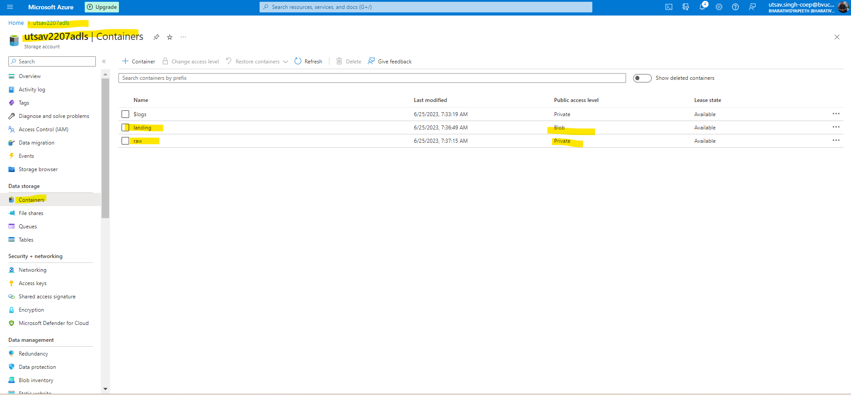

## 6. Create a directory Practice-1 in both container

## 7. Upload any text file in both container inside the Practice-1.

## 8. Delete the file just uploaded

## 9. Try to restore the deleted file.

Step4:-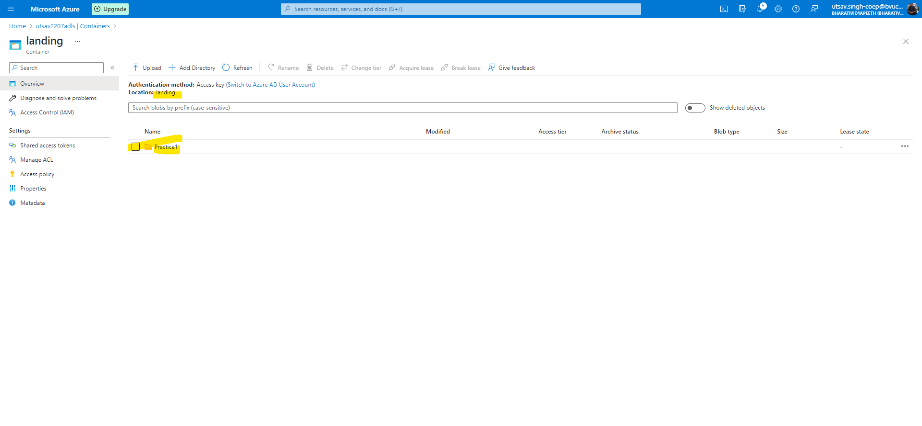

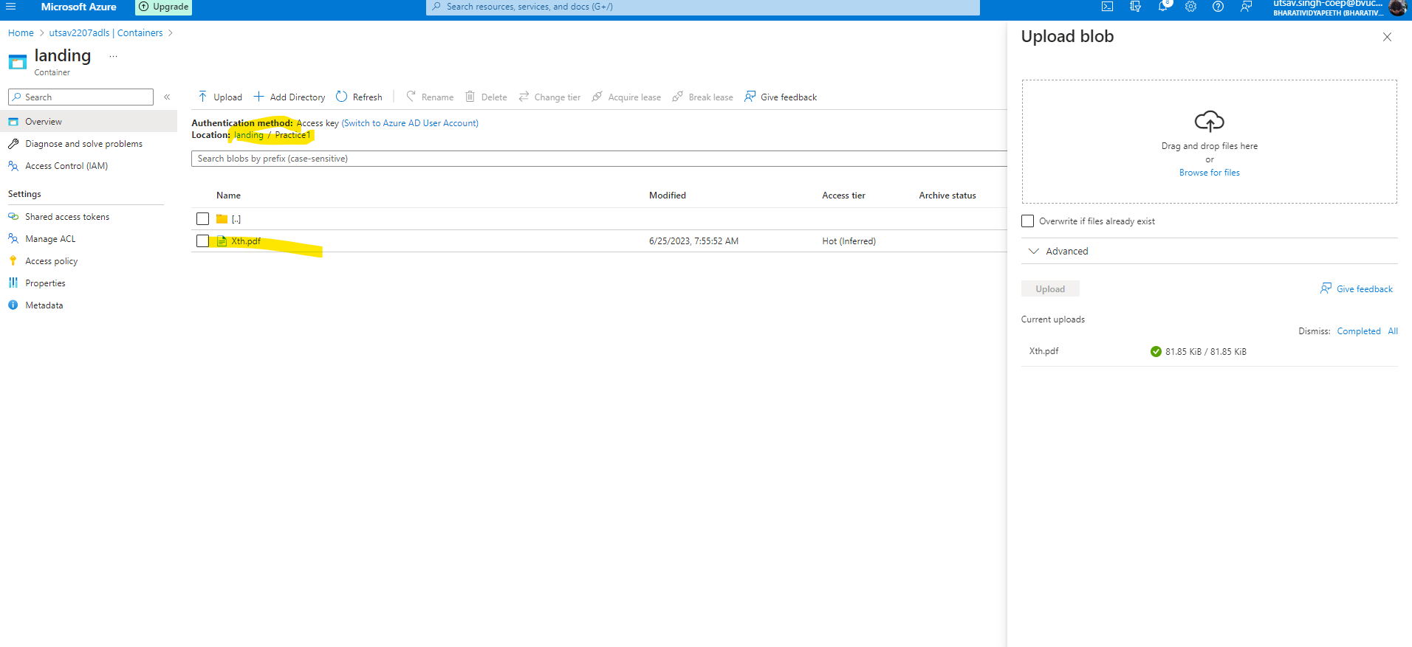

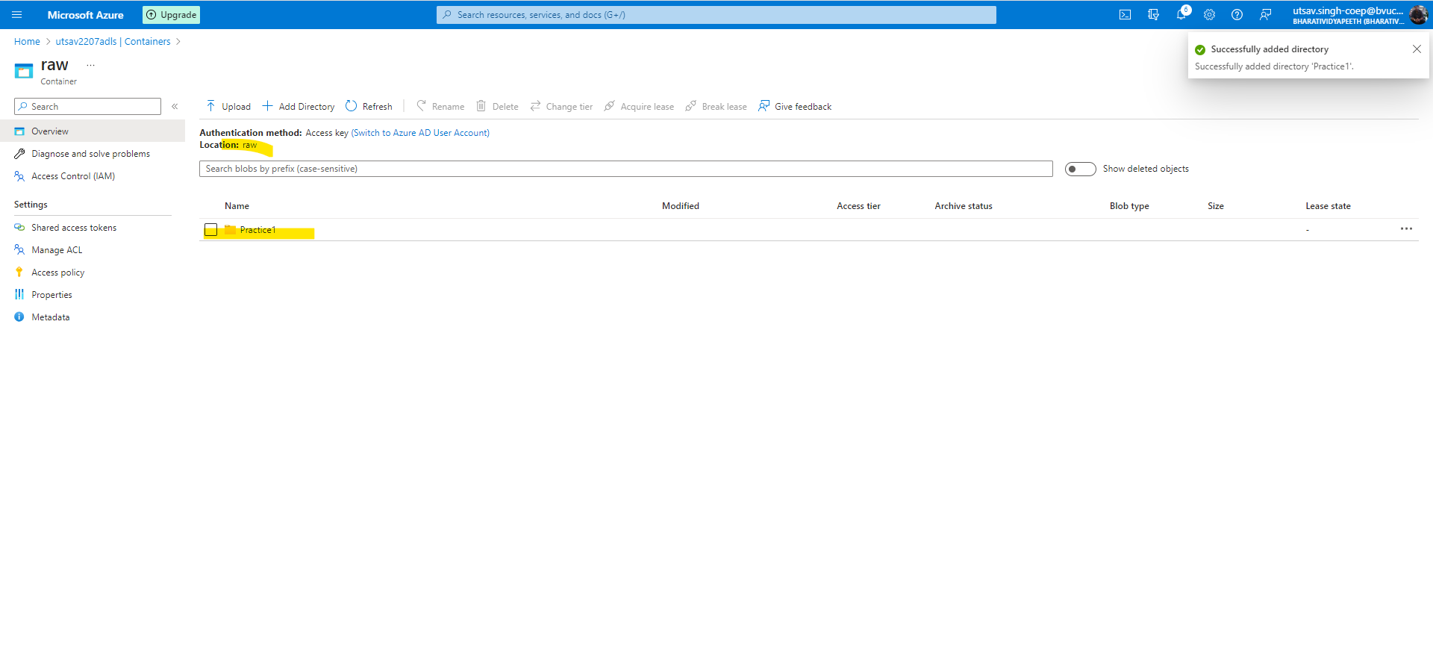

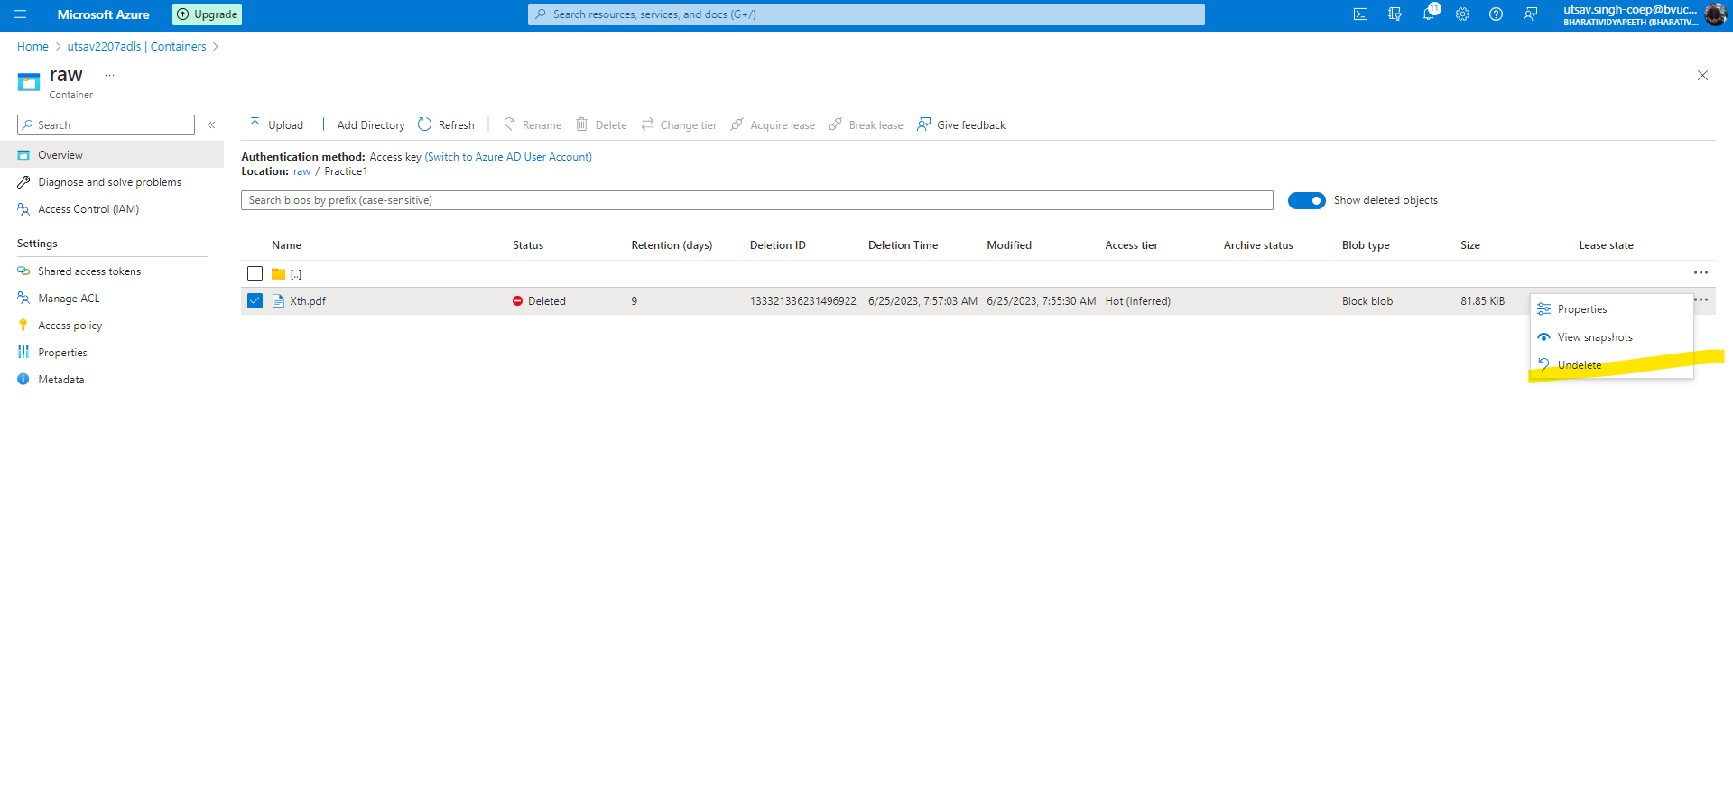

You can delete it and restore it easily from ADLS container.

## **Question 2:**

## 

## 1. Create a Blob storage account with the name: yourname+yourdob+stg

## 2. While making ensure it is in the resource group name: - Azurelib-Academy and the region is US-east

Step1:-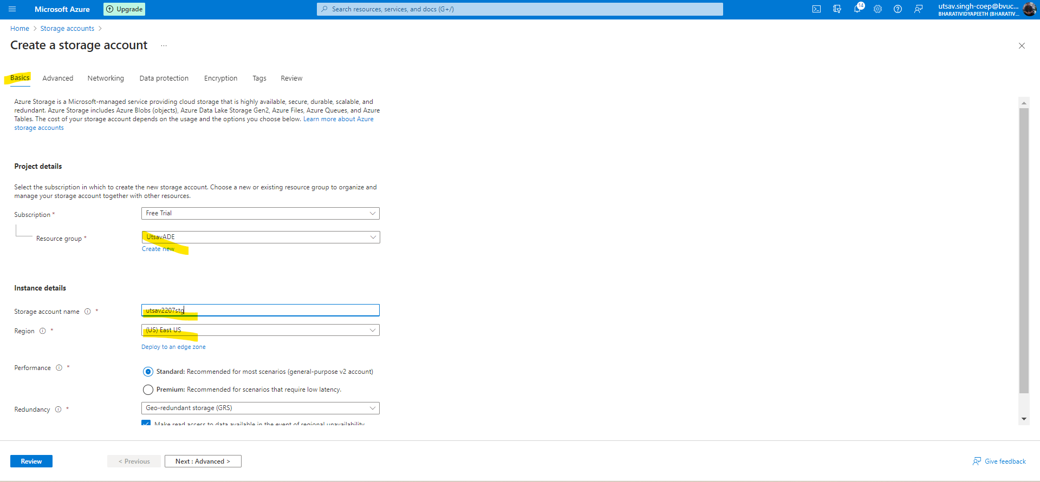

## 3. Try to enable versioning.

Step2:-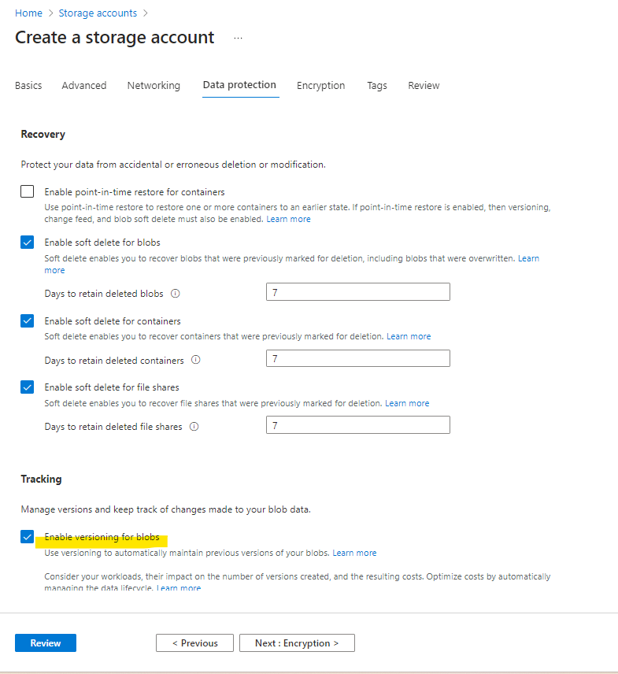

## 4. Create a container name landing (publicly accessible)

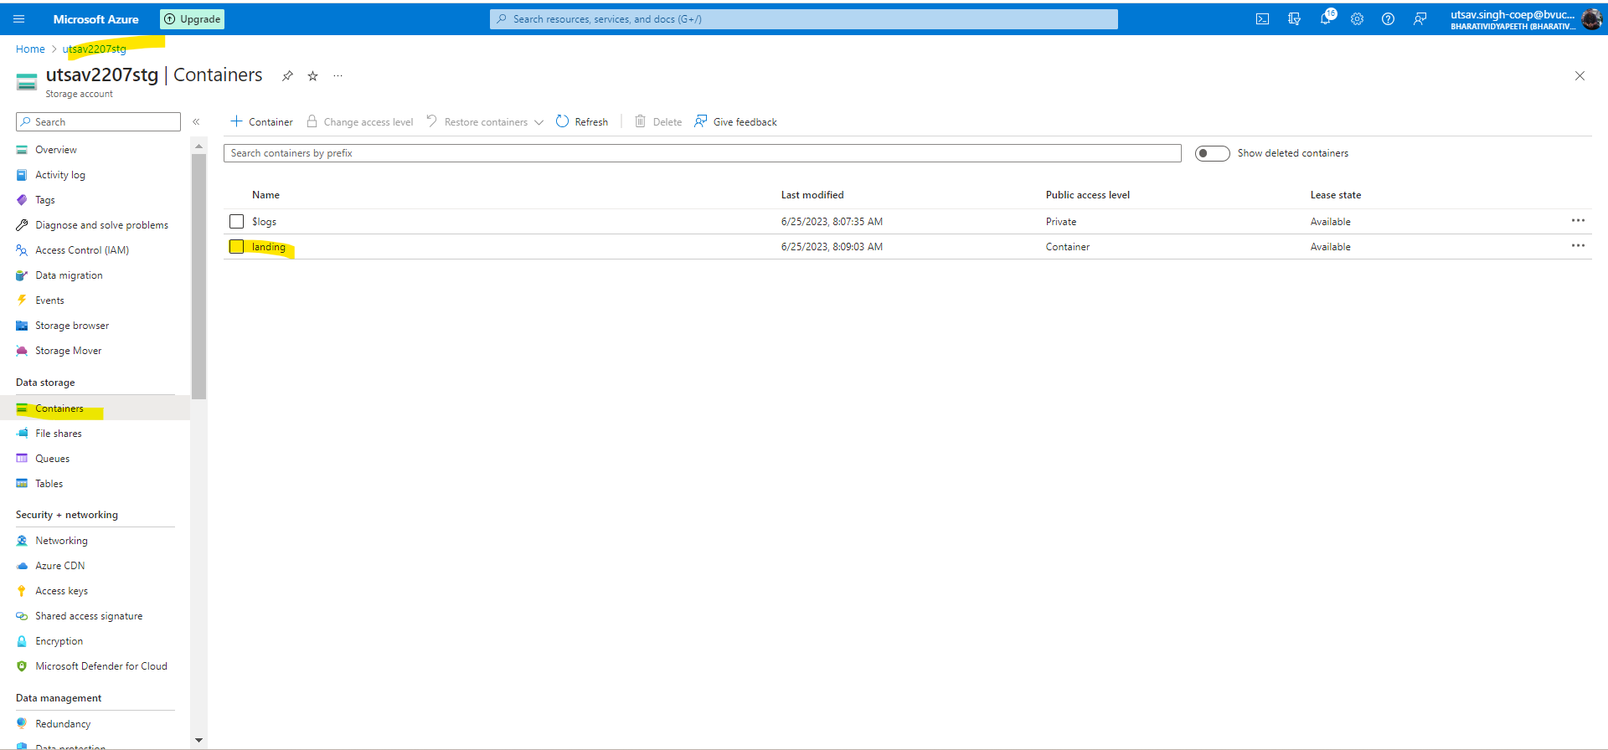

## 5. Upload any text file in container created recently.

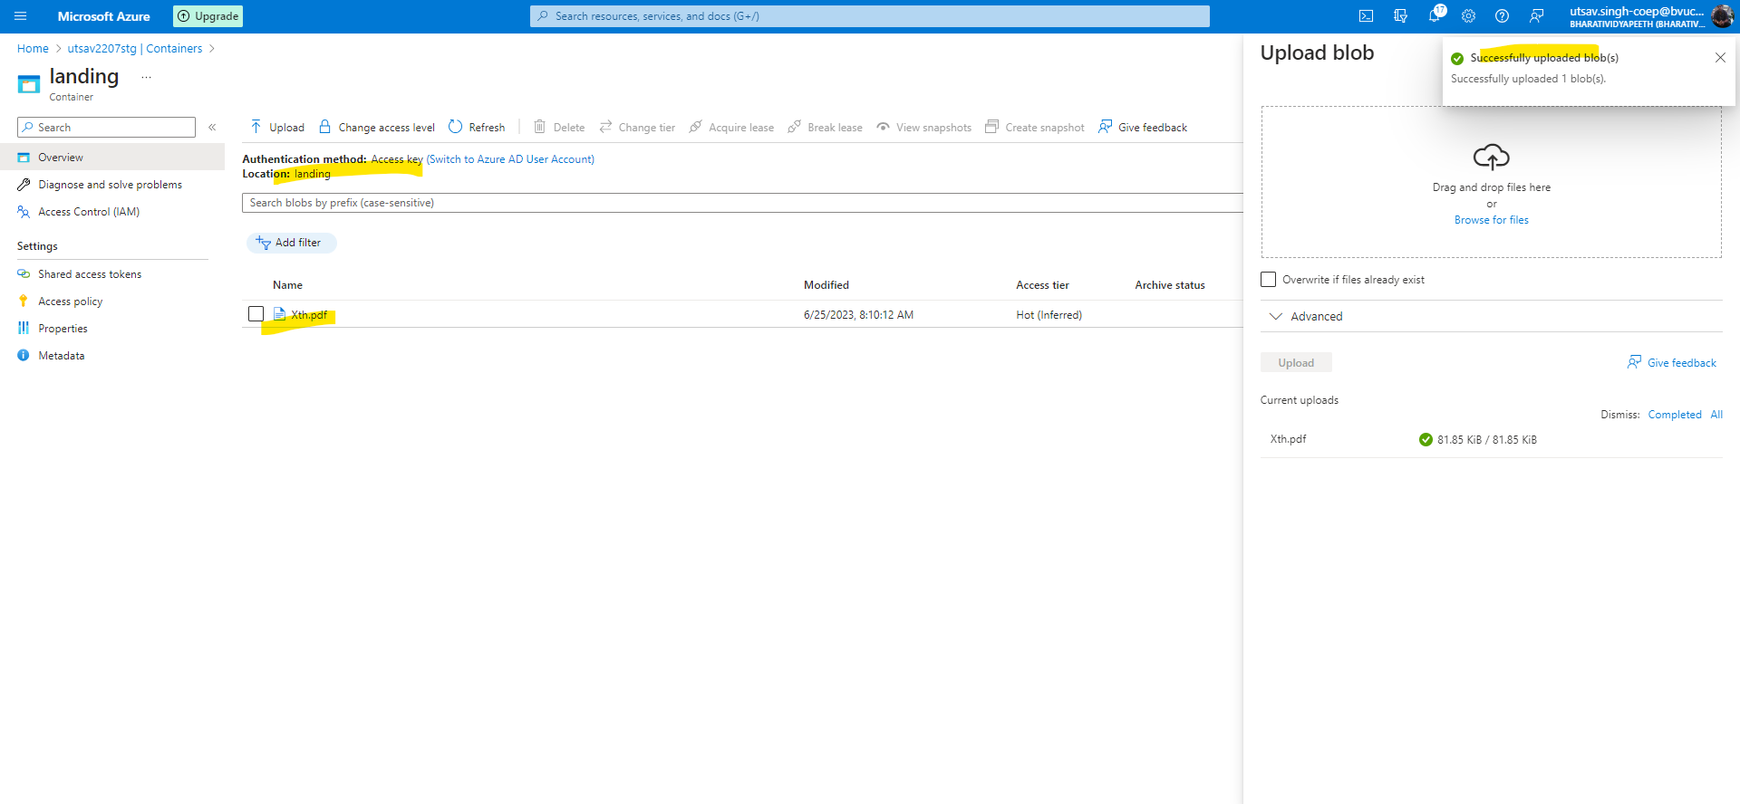

## 6. Upload one more text file with giving folder path in azure blob storage account.

## 7. Try to delete the folder and check if you are allowed to delete.

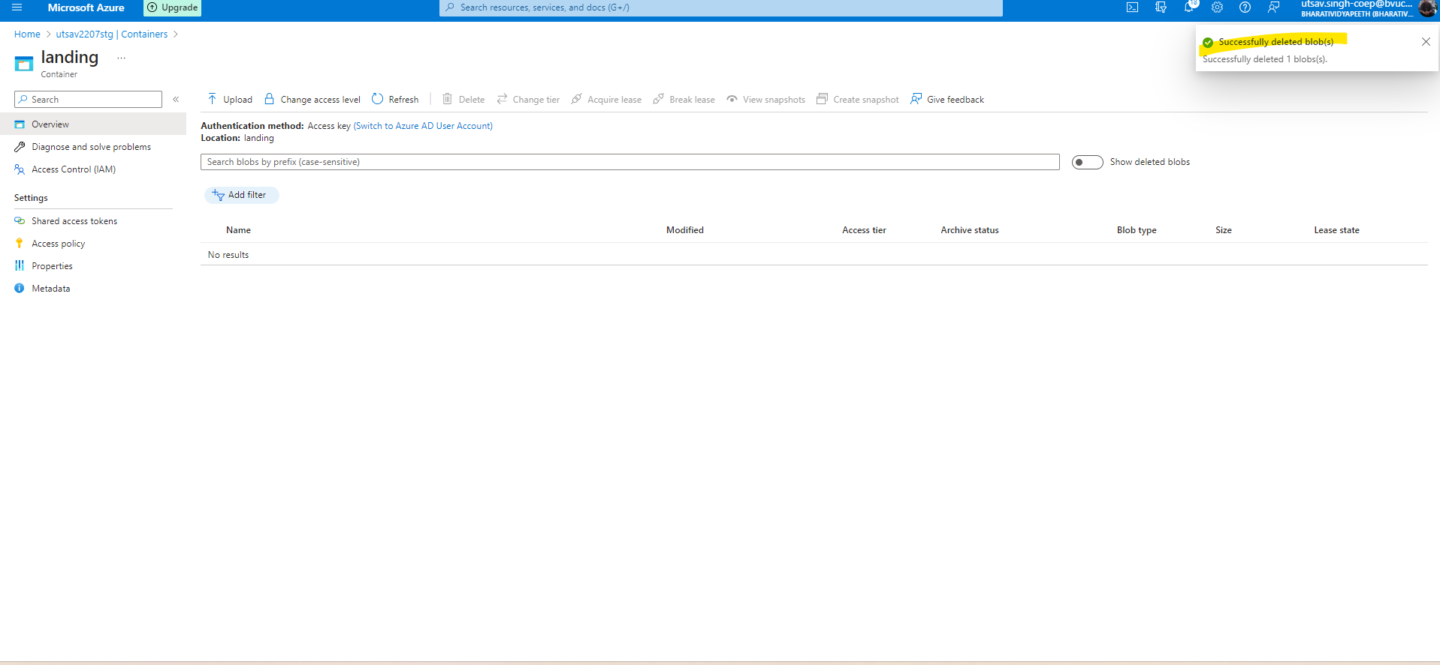

## 8. Now try to delete the file directly without deleting the folder and check if folder also get deleted.

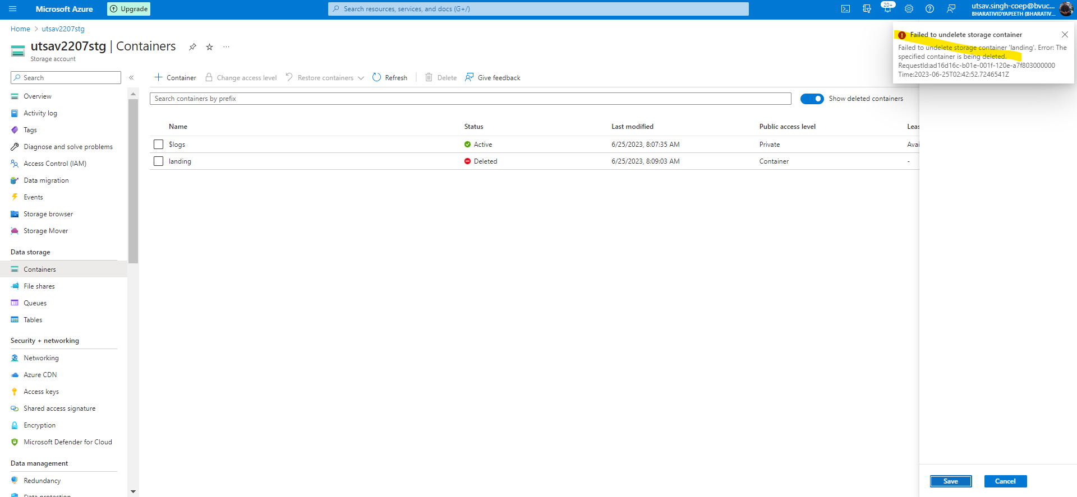

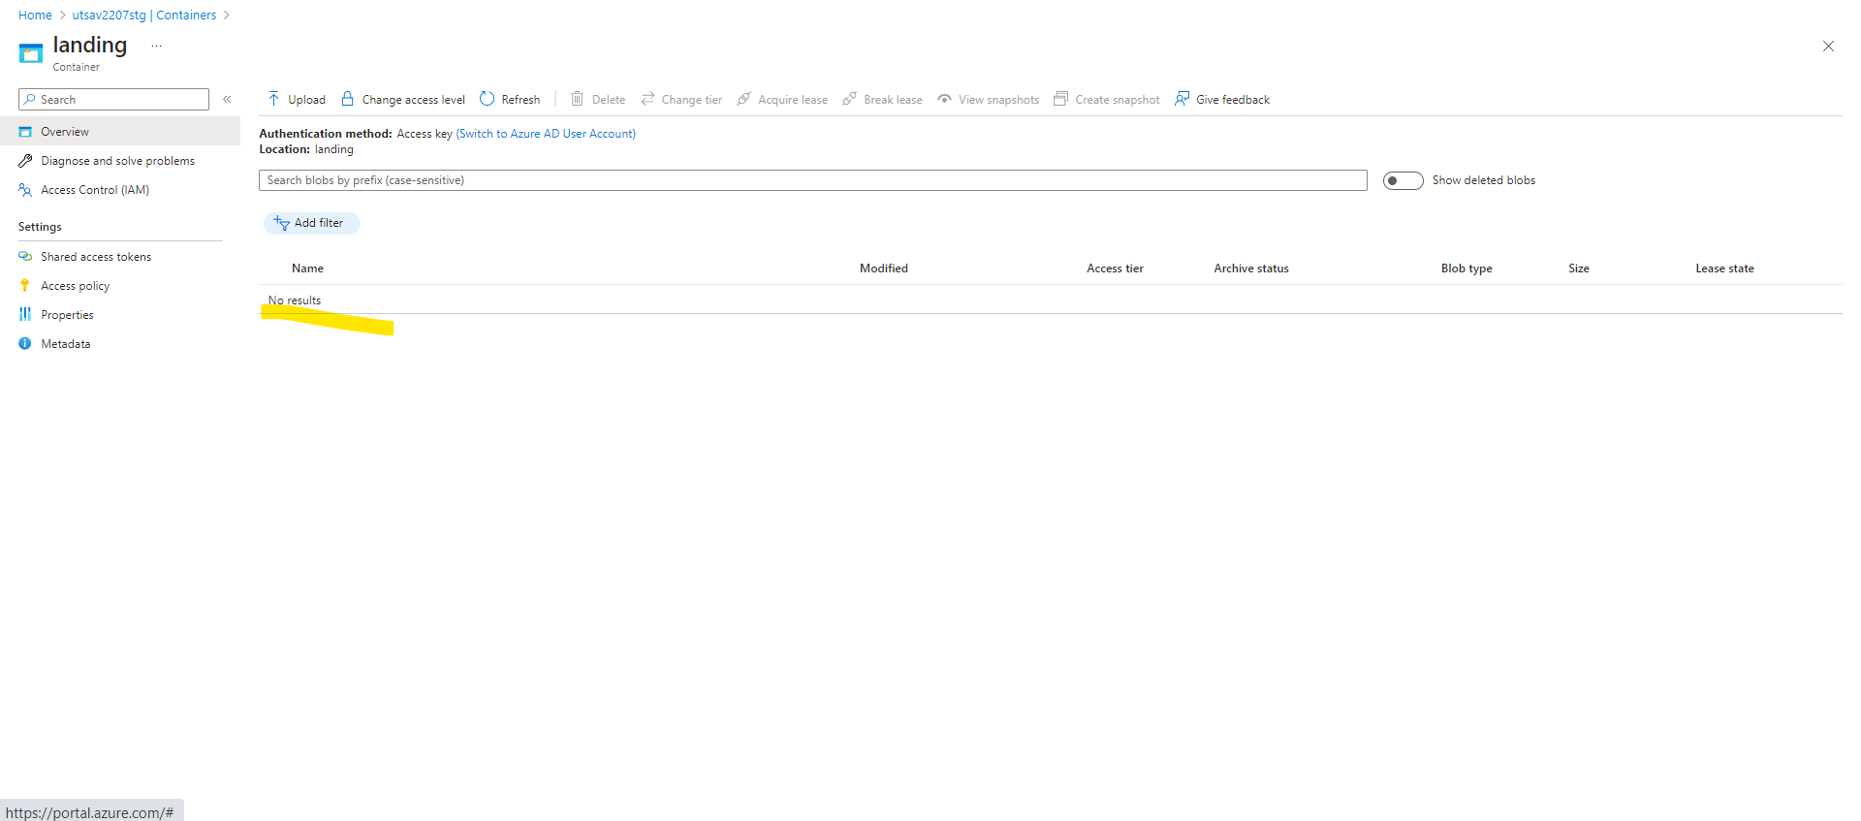

We’ll not restore that file

## 

## 

## 